BridgeU- Software Design Document (SDD)
Version:v 0.3
Date: 09/02/2026

1. Introduction

1.1 Purpose
This Software Design Document summarizes how major features (Daily Briefing, Community, Private Messaging and Authentication) are realized in terms of architecture, data flow and database design, and serve as a bridge between the SRS and the implementation.

1.2 System Overview
BridgeU is a bilingual web platform that helps international students in Thailand connect with each other and with local merchants.
The platform provides three main capabilities:
Daily Briefing System: automatically crawls Thai news from Google News, summarizes it using Qwen AI, and provides bilingual (Chinese / English) briefings.
Community Interaction Platform: a bilingual forum where users can create posts, comment, like, follow others and exchange private messages.
Authentication & Profile Management: secure user registration and login via email or phone, with profile and preference management for students, merchants and administrators.
Internally the system is a standard web application: a Vue.js frontend communicates with a Spring Boot backend via REST APIs; data is stored in a MySQL 8 database; Qwen AI is used for translation, summarization and content moderation.

2. System Architecture

2.1 Logical Architecture
Client (Web Frontend)
- Built with Vue and Element UI/Plus.
- Provides pages for login/registration, Daily Briefing, Community feed and details, messaging and user profiles.
- Uses `axios` to call backend REST APIs over HTTP/HTTPS.
Application Server (Spring Boot Backend)
  - Authentication & Authorization: implemented with Spring Security and the `AppUser` entity; issues JWT tokens to authenticated users.
  - News Module: crawls Thai news from Google News RSS, stores it in the `News` table, generates summaries and translations via Qwen AI, and exposes read-only Daily Briefing APIs.
  - Community Module: manages communities, posts, comments, likes, user-follow relations and user reports, with AI-assisted translation and moderation.
  - Messaging Module: supports one-to-one private conversations between mutually following users.
  - Verification Module: manages email / SMS verification codes for registration and password reset.
Data Storage Layer (MySQL 8)
  - Stores all persistent data as normalized relational tables.
  - Accessed via Spring Data JPA repositories.
External Services
- Qwen AI for summarization, translation and content safety review.
- Email / SMS providers for sending verification codes.
- Google News RSS as the primary news source for the Daily Briefing System.

2.2 Data Flow Diagram (DFD)
2.2.1 Level 0 DFD – Overall System
This context diagram presents BridgeU at the highest level and shows how the three main processes interact with external entities and ‘‘data stores’’. External news content enters the system through ‘‘External News Media’’ and is processed by ‘‘1.0 Daily Briefing System’’. User-generated content and messaging are handled by ‘‘2.0 Community Interaction’’, while registration, login and profile operations are handled by ‘‘3.0 Auth & Profile Management’’.
The diagram also highlights the main data stores: ‘‘Data Store D1 (User & Account Store)’’, ‘‘Data Store D2 (News & Briefing Store)’’, and ‘‘Data Store D3 (Community & Messaging Store)’’, as well as external services such as ‘‘Qwen AI API’’ and the ‘‘Email/SMS Gateway’’.
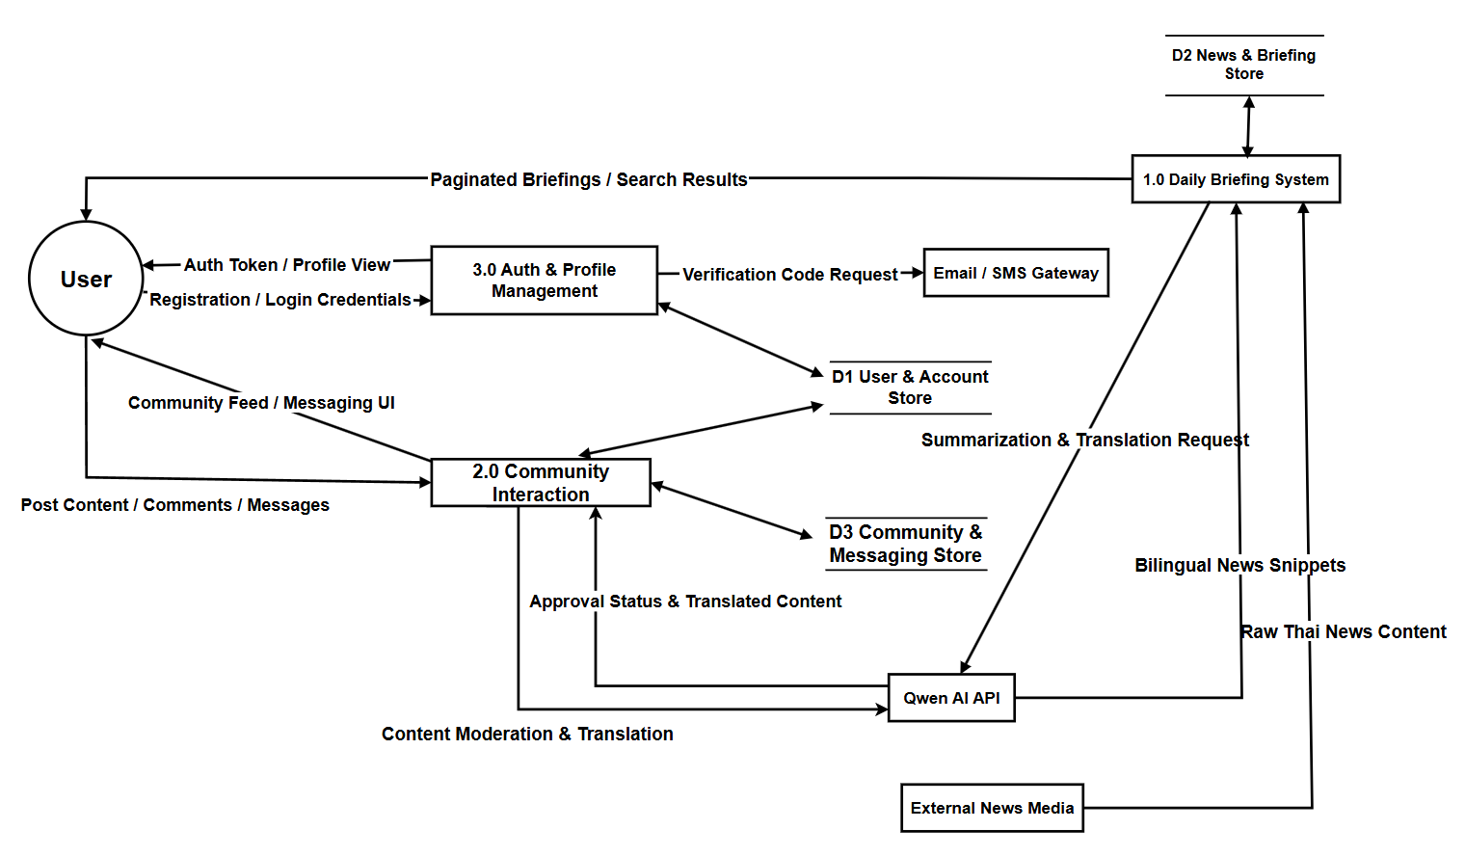

2.2.2 Level 1 DFD – 1.0 Daily Briefing System
This diagram decomposes the ‘‘Daily Briefing System’’ into the internal pipeline implemented in the codebase. At ‘‘8:00 AM’’, a scheduler triggers ‘‘1.1 Scheduled Crawl’’ to fetch raw news from external media sources. The system then runs ‘‘1.2 Filter & Pre-process’’ to clean content and keep relevant items, and calls ‘‘Qwen AI’’ in ‘‘1.3 Summarize & Translate’’ to produce bilingual (ZH/EN) titles and summaries. The processed records are persisted by ‘‘1.4 Persist Data’’ into ‘‘D2 (News Store / `news` table)’’. Finally, users query and browse results via ‘‘1.5 Browse & Search’’ (implemented by `NewsController`), which reads from the same data store and returns paginated `NewsBriefDTO` results.
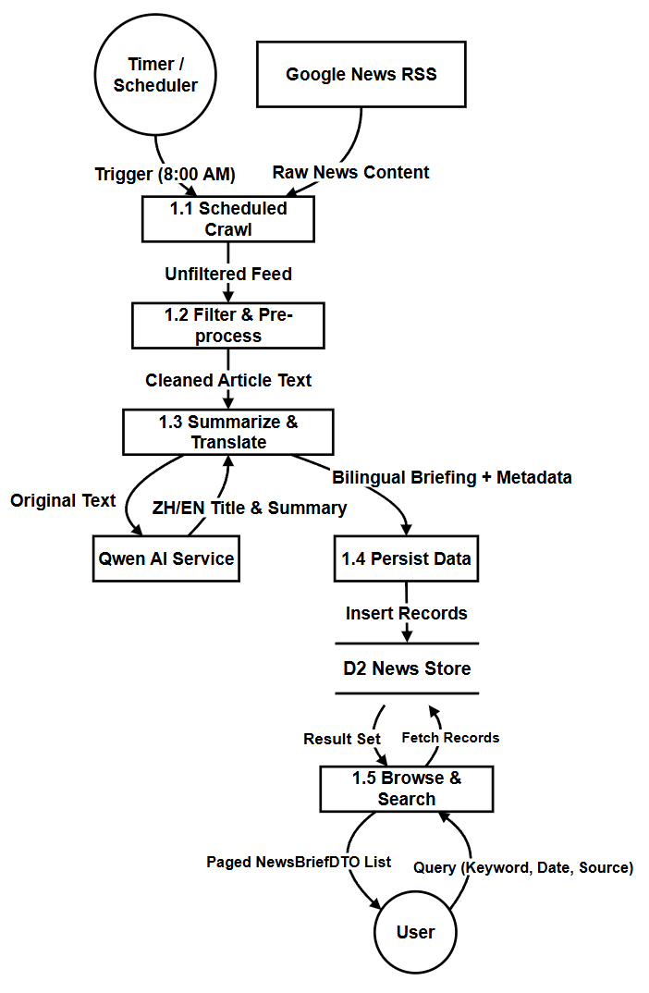
2.2.3 Level 1 DFD – 2.0 Community Interaction
This diagram describes how the ‘‘Community Interaction’’ module handles the full lifecycle of user-generated content
and how each process reads/writes different data stores.
- ‘‘2.1 View Community Feed’’ queries ‘‘D3.1 Posts & Tags’’ and returns a bilingual feed to the user.
- ‘‘2.2 Create/Edit Post’’ submits post text/images, calls ‘‘Qwen AI’’ for translation and safety scoring, and stores results in ‘‘D3.1’’.
- ‘‘2.3 Comment & Like’’ records likes/comments in ‘‘D3.2 Comments & Likes’’ and can request an AI comment summary from ‘‘Qwen AI’’.
- ‘‘2.4 Manage Relationships’’ maintains follow/unfollow operations in ‘‘D3.3 Follow Relations’’.
- ‘‘2.5 Report & AI Moderation’’ stores report reasons in ‘‘D3.5 Reports’’, calls ‘‘Qwen AI’’ for review, and updates post status in ‘‘D3.1’’.
- ‘‘2.6 Private Messaging’’ checks mutual follow via ‘‘D3.3’’, stores chat sessions/messages in ‘‘D3.4 Messages’’, and returns chat history to the user.
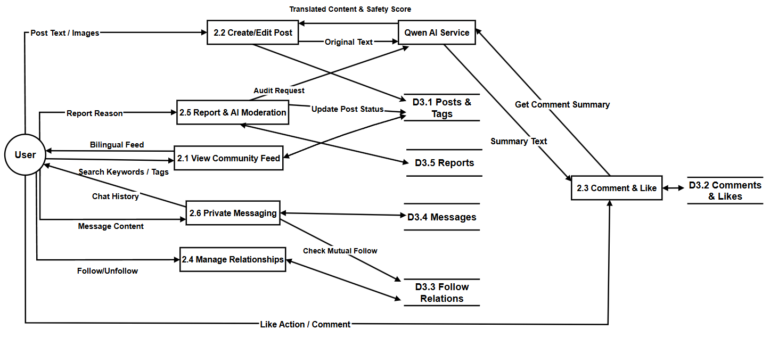
User identity resolution is supported by ‘‘D1 (Users)’’, which is referenced by community actions when needed.

2.2.4 Level 1 DFD – 3.0 Auth & Profile
This diagram focuses on the ‘‘Auth & Profile’’ subsystem (primarily `AuthController` and `UserController`). Users first request a verification code (‘‘3.1’’), which is sent via the ‘‘Email/SMS Provider’’ and stored with expiry in ‘‘DV (Verification Codes / `verification_codes` table)’’. During registration (‘‘3.2’’), the system validates the code
against DV and creates the new account in ‘‘D1 (User & Profiles / `users` table)’’.
For login/logout (‘‘3.3’’), credentials are verified against D1 and the system issues authentication status/token back to the user. Profile updates (‘‘3.4’’) read/write D1. Finally, “View Personal Posts” (‘‘3.5’’) reads the user’s posts and review status from ‘‘DP (Posts Store / `posts` table)’’ and returns the personal activity view.
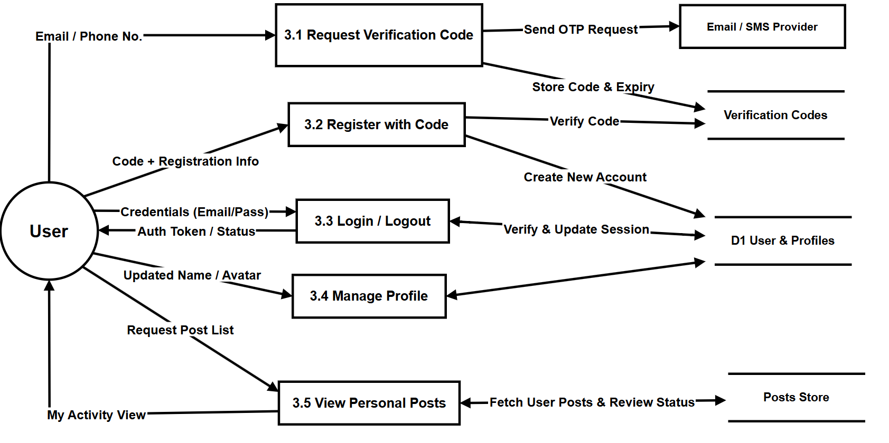

3. Database Design

3.1 Entity Relationship Diagram (ERD)
The following diagram gives a system-wide view of all key entities in BridgeU and how they relate to each other. It mirrors the physical database schema used by the Spring Boot backend and can be read as follows:
  - USERS :Core identity table for all roles (students, merchants, admins). Stores login credentials (`username`, `password_hash`),contact info (`email`, `phone`), profile preferences (`preferred_language`) and status flags (`enabled`, `created_at`).

  - VERIFICATION_CODE : Stores email/phone-based OTP codes for registration and password reset. `identifier` links logically to a user’s email or phone, and each record includes type (EMAIL/SMS) and purpose (REGISTER/RESET_PASSWORD).

  - POSTS / COMMENTS / POST_LIKES – Represent community content and interactions. `POSTS` contains multilingual content and AI-moderation fields (`status`, `ai_confidence`, `ai_result`, `review_note`); `COMMENTS` and `POST_LIKES` reference `POSTS` and `USERS` to record who commented/liked what and when.

  - USER_FOLLOWS: Many-to-many relation capturing who follows whom; used both for community features (mutual follow list) and as a permission gate for private messaging.

  - CONVERSATION / MESSAGE: Model one-to-one private chats. `CONVERSATION` stores the pair of users and latest activity time,while `MESSAGE` stores individual messages, including sender/receiver, content, read flag and timestamps.

  - REPORT: Stores user reports against posts or comments (`targetId`, `targetType`), together with status and timestamps,supporting the hybrid AI + human moderation flow.

  - NEWS: Stores crawled Thai news and their bilingual titles/summaries, as used by the Daily Briefing feature(`title_en/zh`, `summary_en/zh`, `original_url`, `source`, `publish_date`, `create_time`).
Together these entities support authentication, community interactions, messaging, content safety and the daily news briefing.

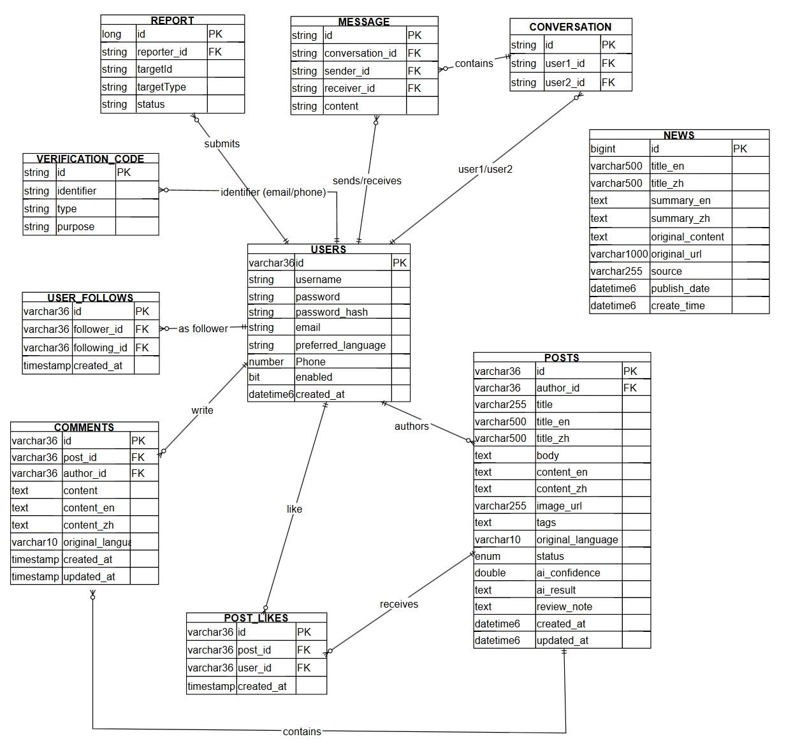

3.2 Data Dictionary
Table Name | Field Name | Data Type | Description
Users | id | varchar(36)  (PK) | Unique identifier for each user
 | username | string | Login username
 | password | string | plaintext password field if present
 | password_hash | string | Hashed password used for authentication
 | email | string | Email address
 | preferred_language | string | UI language preference (zh/en)
 | phone | number | Phone number
 | enabled | bit | Whether the account is enabled
 | created_at | datetime | Account creation timestamp
Verification_  code | id | string  (PK) | Verification code record ID
 | identifier | string | Email address or phone number
 | type | string | Code type (EMAIL/SMS)
 | purpose | string | Code purpose (REGISTER/RESET_PASSWORD)
Posts | id | varchar(36)  (PK) | Post ID
 | author_id | varchar(36)  (FK) | References `USERS.id` (post author)
 | title | varchar(255) | Original title
 | title_en | varchar(500) | English title
 | title_zh | varchar(500) | Chinese title
 | image_url | varchar(255) | Optional image URL
 | tags | text | Tag list
 | original_  language | varchar(10) | Detected original language(zh/en)
 | status | enum | Moderation status (PENDING_REVIEW/APPROVED/REJECTED)
 | ai_confidence | double | AI moderation confidence score
 | ai_result | text | AI moderation result payload
 | review_note | text | AI review note
 | created_at | datetime | Creation time
 | updated_at | datetime | Update time
Comments | id | varchar(36)  (PK) | Comment ID
 | post_id | varchar(36)  (FK) | References `POSTS.id`
 | author_id | varchar(36)  (FK) | References `USERS.id`
 | content | text | Original comment content
 | content_en | text | English comment content
 | content_zh | text | Chinese comment content
 | original_  language | varchar(10) | Detected original language
 | created_at | timestamp | Creation time
 | updated_at | timestamp | Update time
Post_Likes | id | varchar(36)  (PK) | Like record ID
 | post_id | varchar(36)  (FK) | References `POSTS.id`
 | user_id | varchar(36)  (FK) | References `USERS.id`
 | created_at | timestamp | Like time
User_  Follows | id | varchar(36)  (PK) | Follow relationship ID
 | follower_id | varchar(36)  (FK) | References `USERS.id` (follower)
 | following_id | varchar(36)  (FK) | References `USERS.id` (followed user)
 | created_at | timestamp | Follow time
Conversation | id | string(PK) | Conversation ID
 | user1_id | string(FK) | References `USERS.id` (participant 1)
 | user2_id | string(FK) | References `USERS.id` (participant 2)
 | created_at | datetime | Conversation creation time
 | last_message_at | datetime | Timestamp of the latest message
Message | id | string(PK) | Message ID
 | conversation_id | string(FK) | References `CONVERSATION.id`
 | sender_id | string(FK) | References `USERS.id`
 | receiver_id | string(FK) | References `USERS.id`
 | content | text | Message content
 | is_read | bit | Read flag
 | read_at | datetime | Read time
 | created_at | datetime | Created time
Report | id | long | Report ID
 | reporter_id | string(FK) | References `USERS.id` (reporter)
 | targetId | string | Target entity ID (post/comment)
 | targetType | string | Target type (POST/COMMENT)
 | status | string | Report status
 | created_at | datetime | Created time
News | id | bigint  (PK) | News ID
 | title_en | varchar(500) | English title
 | title_zh | varchar(500) | Chinese title
 | summary_en | text | English summary
 | summary_zh | text | Chinese summary
 | original_content | text | Original article content
 | original_url | Varchar  (1000) | Original URL
 | source | varchar(255) | Source website name
 | publish_date | datetime | Publication time
 | create_time | datetime | Insert time (when stored)

4. Detailed Design

4.1 Class Diagram (if Object-Oriented)

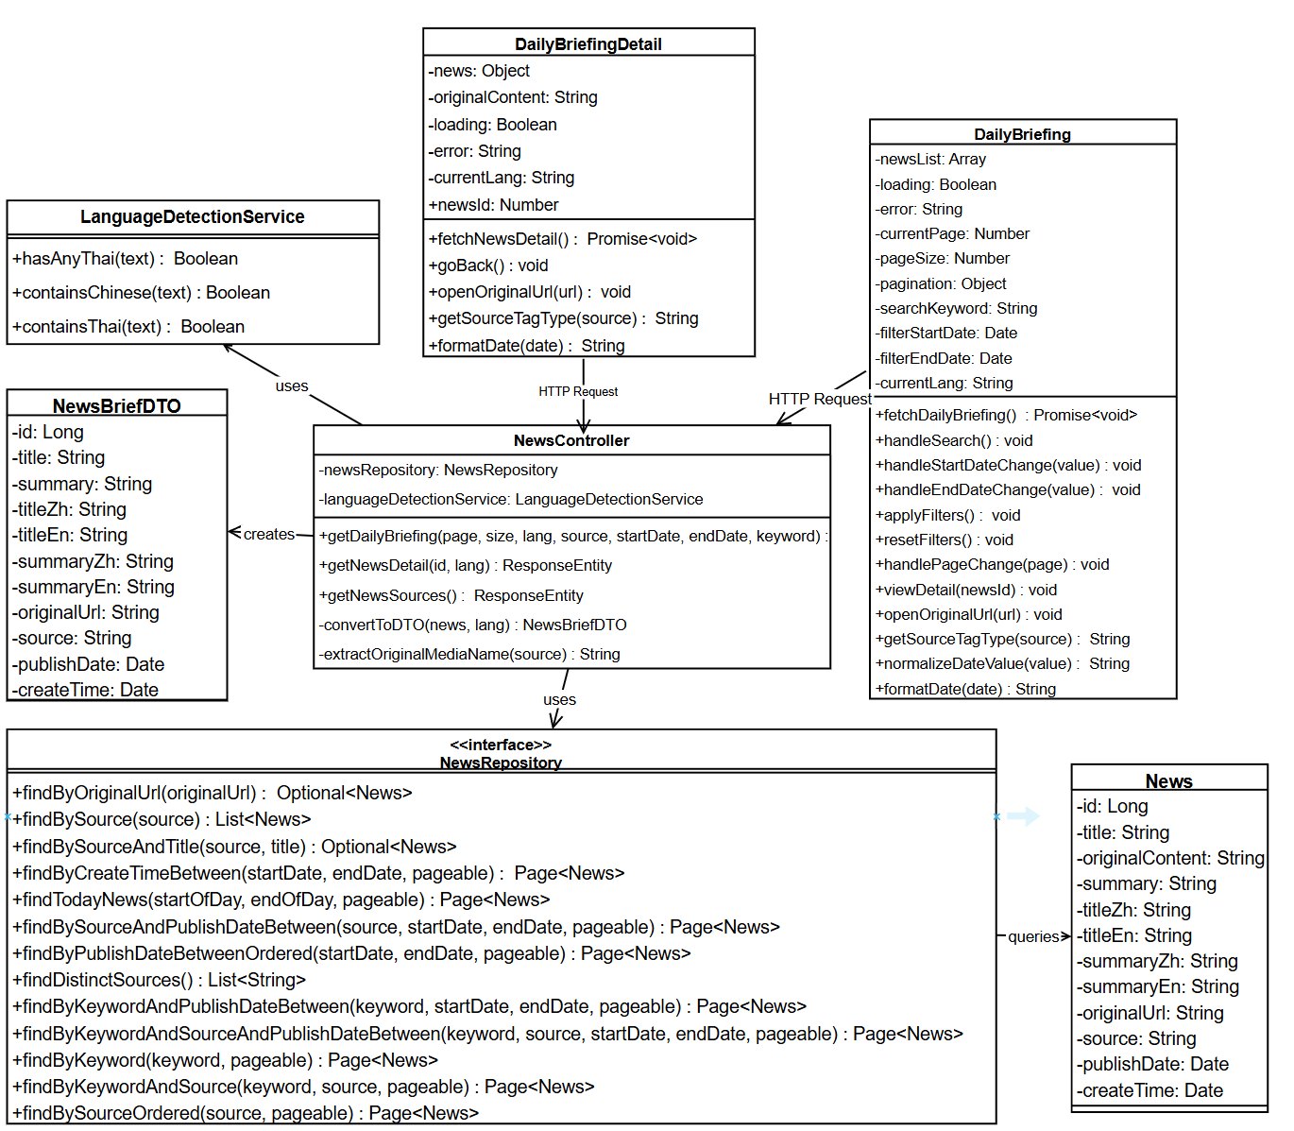
4.1.1 Feature1

4.1.1.1 DailyBriefing
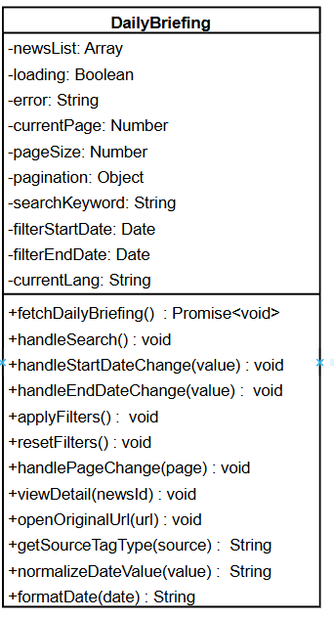

Attributes:
ID | Name | Description | Type
1 | newsList | Array containing the list of Daily Briefing news items to be displayed | Array
2 | loading | Boolean flag indicating if the news data is currently being fetched | Boolean
3 | error | String containing error message if data fetching fails | String
4 | currentPage | Current page number for pagination (1-based) | Number
6 | pageSize | Number of news items to display per page | Number
7 | searchKeyword | String containing the keyword entered by the user for searching news | String
8 | filterStartDate | Date object representing the start date for filtering news by publication date | Date
9 | filterEndDate | Date object representing the end date for filtering news by publication date | Date
10 | currentLang | String representing the current interface language ("zh" for Chinese, "en" for English) | String

Methods:
ID | Name | Description | Parameter | Return Type
1 | fetchDailyBriefing | Fetches Daily Briefing news items from the backend API with pagination, search, and filter parameters. Sets loading=true, calculates 0-based page number, builds params object with page, size, lang, keyword (if provided), startDate and endDate.Sends GET request to /api/news/daily-briefing. On success, updates newsList and pagination object. Handles errors and sets loading=false in finally block. | None | Promise<void>
2 | handleSearch | Handles search action by resetting currentPage to 1 and calling fetchDailyBriefing(). This ensures search results start from the first page. | None | Void
3 | handleStartDateChange | Updates the filterStartDate when user selects a start date | value: Date \null | void
4 | handleEndDateChange | pdates the filterEndDate when user selects an end date | value: Date \null | void
5 | applyFilters | Validates date range (checks if startDate > endDate, shows warning if invalid). If valid, resets currentPage to 1 and calls fetchDailyBriefing() to fetch filtered results. Note: fetchDailyBriefing() internally calls normalizeDateValue() to normalize date values before sending to API. | None | void
6 | resetFilters | Clears all filter conditions: sets searchKeyword='', filterStartDate=null, filterEndDate=null, resets currentPage to 1, and calls fetchDailyBriefing() to reload all news without filters. | None | void
7 | handlePageChange | Handles pagination by updating currentPage to the new page number and calling fetchDailyBriefing() to fetch the corresponding page. Scrolls to top after page change. | page: Number | void
8 | viewDetail | Emits an event to navigate to the news detail page for a specific news item | newsId: Number | void
9 | openOriginalUrl | Opens the original news article URL in a new browser tab | url: String | void
10 | getSourceTagType | Returns the Element UI tag type (primary/success/info) based on the news source | source: String | String
11 | normalizeDateValue | Normalizes date value to DD-MM-YYYY format string. Handles Date objects (extracts year, month, day), string values (validates DD-MM-YYYY format, ignores incomplete inputs with letters), and null values. Returns null for invalid inputs. | value: Date \String | String \null
12 | formatDate | Formats a date object to "DD-MM-YYYY HH:mm" format string | date: Date \String | String

4.1.1.2 DailyBriefingDetail
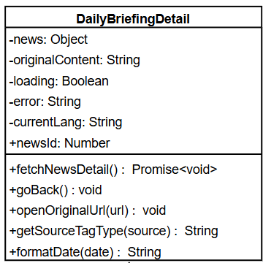

Attributes:
ID | Name | Description | Type
1 | news | Object containing the detailed information of a single Daily Briefing news item | Object
2 | originalContent | String containing the original content of the news article | String
3 | loading | Boolean flag indicating if the news detail data is currently being fetched | Boolean
4 | error | String containing error message if data fetching fails | String
5 | currentLang | String representing the current interface language ("zh" for Chinese, "en" for English) | String
6 | newsId | Number representing the ID of the news item to display (passed as prop) | Number

Methods:
ID | Name | Description | Parameter | Return Type
1 | fetchNewsDetail | Fetches detailed information of a single news item from the backend API using newsId. Sets loading=true, error=null, builds params with lang (currentLang or 'en'), sends GET request to /api/news/daily-briefing/{id}. First checks response.status === 200, then checks response.data.success. On success, updates news = response.data.data and originalContent = response.data.originalContent. Handles errors: 404 (shows localized notFound message), 401 (shows login expired message, handled by interceptor), 500 (shows error message from response), network errors (shows localized networkError message). Sets loading=false in finally block. | None | Promise<void>
2 | goBack | Emits an event to navigate back to the Daily Briefing list page | None | Void
3 | openOriginalUrl | Opens the original news article URL in a new browser tab | url: String | Void
4 | getSourceTagType | Returns the Element UI tag type (primary/success/info) based on the news source | source: String | String
5 | formatDate | Formats a date object to "DD-MM-YYYY HH:mm" format string | date: Date \String | String

4.1.1.3 NewsController
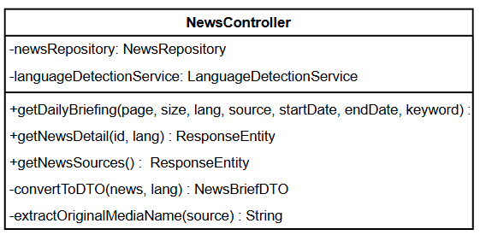
Attributes:
ID | Name | Description | Type
1 | newsRepository | Instance of NewsRepository for database operations | NewsRepository
2 | languageDetectionService | Instance of LanguageDetectionService for detecting Thai and Chinese content | LanguageDetectionService

Methods:
ID | Name | Description | Parameter | Return Type
1 | getDailyBriefing | Handles GET request to retrieve paginated Daily Briefing news list with optional filters (keyword, date range, source). Returns ResponseEntity with paginated news data. | page: int, size: int, lang: String, source: String, startDate: String, endDate: String, keyword: String | ResponseEntity<Map<String, Object>>
2 | getNewsSources | Handles GET request to retrieve detailed information of a single news item by ID. Returns ResponseEntity with news detail data. | id: Long, lang: String | ResponseEntity<Map<String, Object>>
3 | getNewsSources | Handles GET request to retrieve list of distinct news sources. Returns ResponseEntity with list of source names. | None | ResponseEntity<Map<String, Object>>
4 | convertToDTO | Converts News entity to NewsBriefDTO based on language preference. Ensures no Thai content is displayed on the website. | news: News, lang: String | NewsBriefDTO
5 | extractOriginalMediaName | Extracts original media name from source string (e.g., "Google News (Thailand) - Bangkok Post" -> "Bangkok Post") | source: String | String

4.1.1.4 NewsRepository
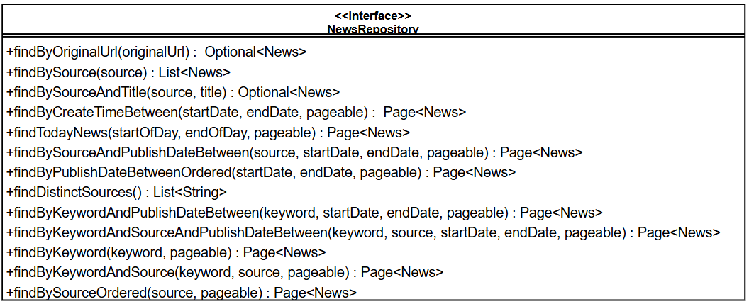

Methods:
ID | Name | Description | Parameter | Return Type
1 | findByOriginalUrl | Finds a news item by its original URL (for deduplication) | originalUrl: String | Optional<News>
2 | findBySource | Finds all news items by source website name | source: String | List<News>
3 | findBySourceAndTitle | Finds a news item by source website name and title | source: String, title: String | Optional<News>
4 | findByCreateTimeBetween | Finds news items within specified date range based on createTime (with pagination) | startDate: Date, endDate: Date, pageable: Pageable | Page<News>
5 | findTodayNews | Finds today's news items based on publishDate (with pagination) | startOfDay: Date, endOfDay: Date, pageable: Pageable | Page<News>
6 | findBySourceAndPublishDateBetween | Finds news items by source and publish date range (with pagination) | source: String, startDate: Date, endDate: Date, pageable: Pageable | Page<News>
7 | findByPublishDateBetweenOrdered | Finds news items within publish date range, ordered by publishDate DESC (with pagination) | startDate: Date, endDate: Date, pageable: Pageable | Page<News>
8 | findDistinctSources | eturns list of distinct news source names | None | List<String>
9 | findByKeywordAndPublishDateBetween | Searches news items by keyword (in title, content, summary, translations) and publish date range (with pagination) | keyword: String, startDate: Date, endDate: Date, pageable: Pageable | Page<News>
10 | findByKeywordAndSourceAndPublishDateBetween | Searches news items by keyword, source, and publish date range (with pagination) | keyword: String, source: String, startDate: Date, endDate: Date, pageable: Pageable | Page<News>
11 | findByKeyword | Searches news items by keyword across all historical news (with pagination) | keyword: String, pageable: Pageable | Page<News>
12 | findByKeywordAndSource | Searches news items by keyword and source across all historical news (with pagination) | keyword: String, source: String, pageable: Pageable | Page<News>
13 | findBySourceOrdered | Finds news items by source, ordered by publishDate DESC (with pagination) | source: String, pageable: Pageable | Page<News>

4.1.1.5 News
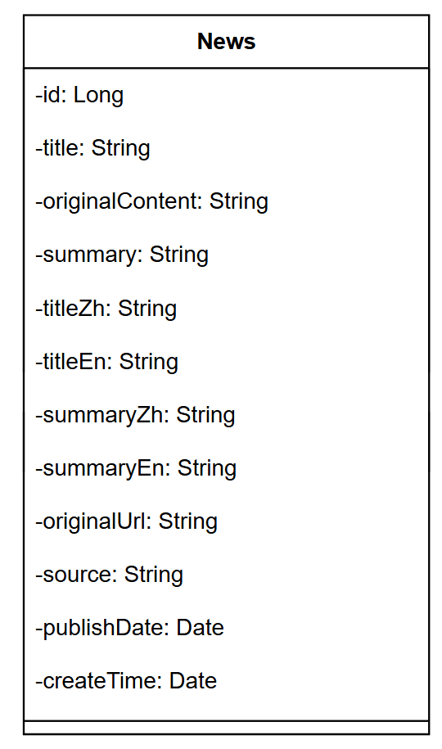
Attributes:
ID | Name | Description | Type
1 | Id | Primary key ID of the news item | Long
2 | title | Original news title | String
3 | originalContent | Original content of the news article (stored as TEXT) | String
4 | summary | AI-generated summary of the news article | String
5 | titleZh | Chinese translation of the title | String
6 | titleEn | English translation of the title | String
7 | summaryZh | Chinese translation of the summary | String
8 | summaryEn | English translation of the summary | String
9 | originalUrl | Original article URL from the source website | String
10 | source | Source website name | String
11 | publishDate | Publication date from the source website | Date
12 | createTime | imestamp when the news was crawled and stored | Date

4.1.1.6 NewsBriefDTO
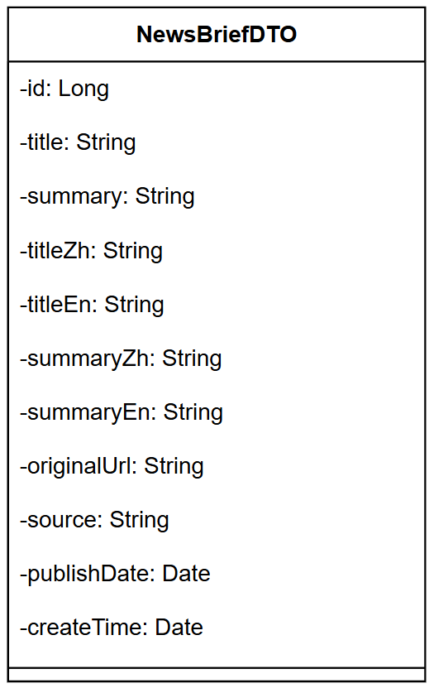

Attributes:
ID | Name | Description | Type
1 | Id | Primary key ID of the news item | Long
2 | Title | news title (language-specific based on user preference) | String
3 | Summary | news summary (language-specific based on user preference) | String
4 | titleZh | Chinese translation of the title | String
5 | titleEn | English translation of the title | String
6 | summaryZh | Chinese translation of the summary | String
7 | summaryEn | English translation of the summary | String
8 | originalUrl | Original article URL from the source website | String
9 | source | Source website name | String
10 | publishDate | Publication date from the source website | Date
11 | createTime | Timestamp when the news was crawled and stored | Date

4.1.1.7 LanguageDetectionService

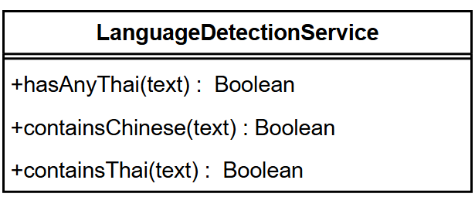
Methods:
ID | Name | Description | Parameter | Return Type
1 | hasAnyThai(text) | Returns true if the given text contains any Thai character, otherwise false. | text: String | Boolean
2 | containsChinese(text) | Returns true if the text contains enough Chinese characters (at least 2 or ≥ 20% of the text). | text: String | Boolean
3 | 3 | containsThai(text) | text: String | Boolean

4.2 Component Design
- Component A: AI-Driven News Automation Engine - Responsible for the data extraction and intelligent processing of the Daily Briefing system.
- Component B: Bilingual Community Controller- Manage the business logic of community posts (Posts), comments (Comments), and the tag filtering system.
- Component C: Authentication & Security Gateway- Handling multi-channel registration (email/mobile phone) and stateless session management
- Component D: IInstant messaging and relationship manager-channel registration (email/mobile phone) and manage the two-way follow-up relationship between users as well as the delivery of private messages.

5. Interface Design

5.1 Wireframes / Mockups

